Solution for Problem4 of Module 3 Assignment
- Star Schema is used as only five dimensions are there.
- A New Fact Table Name SalesRecord is made.
It maintains the entry for each productService/Merchandise bought.
It has following fields:
- SalesRecordNo (Primary Key)
- SalesQty( As it was there in Contains Table)
- SalesUnitPrice(Price of Merchandise,Price of Service,may be ServiceCategory,Special Events,Membership Price from MemberType Table)
- SalesTotalAmt (Keep Track of Total Money Earned)
- isService (Yes or No)
To check entry recorded is of Service or not.
- isMerchandise (Yes or No)
To check Entry recorded is of merchandise or not.
- Other 5 Dimension Tables are as follows:
Franchise
FranchId (primary key)
FranchRegion
FranchPostalCode
FranchModelType

Member
MemId (Primary Key)
MemName
MemZip
MemDate(MembershipDate)
MemEmail
MemType (Taken from ERD MemType Table)
(Default values for Guest, Corporate Cust)

Calendar
CallId (primary key)
CallDay
CallMonth
CallYear

ProductService
ProdId(Primary Key)
ProdName
ProdType (Special Event,Service,MemberShip)

Merchandise
MerchId (Primary Key)
MerchName
MerchType
SalesRecord Of ProductService/Merchandise Bought By Member On Calendar Suppiled By Franchise
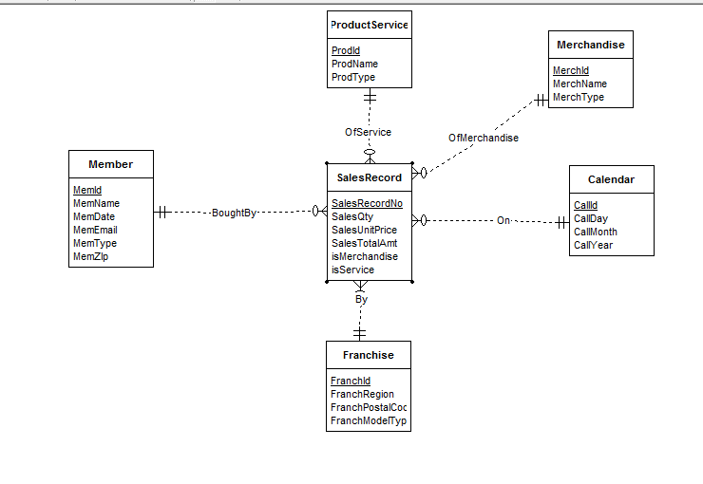
The diagram shows the star schema , with salesrecord as the middle and other dimensions have 1 to Many relationships to it.
Each Entry into the database contains the record of the productservice whether it is Service or Special Event into the database or Membership(Gold,Platinum,Value) or of merchandise.

